DAT 515 uCertify Lab Activity Worksheet

Module Labs
Module 1
1.1.6
1.1.7
1.7.2
1.7.3

Lab Screenshots
Lab 1.1.6
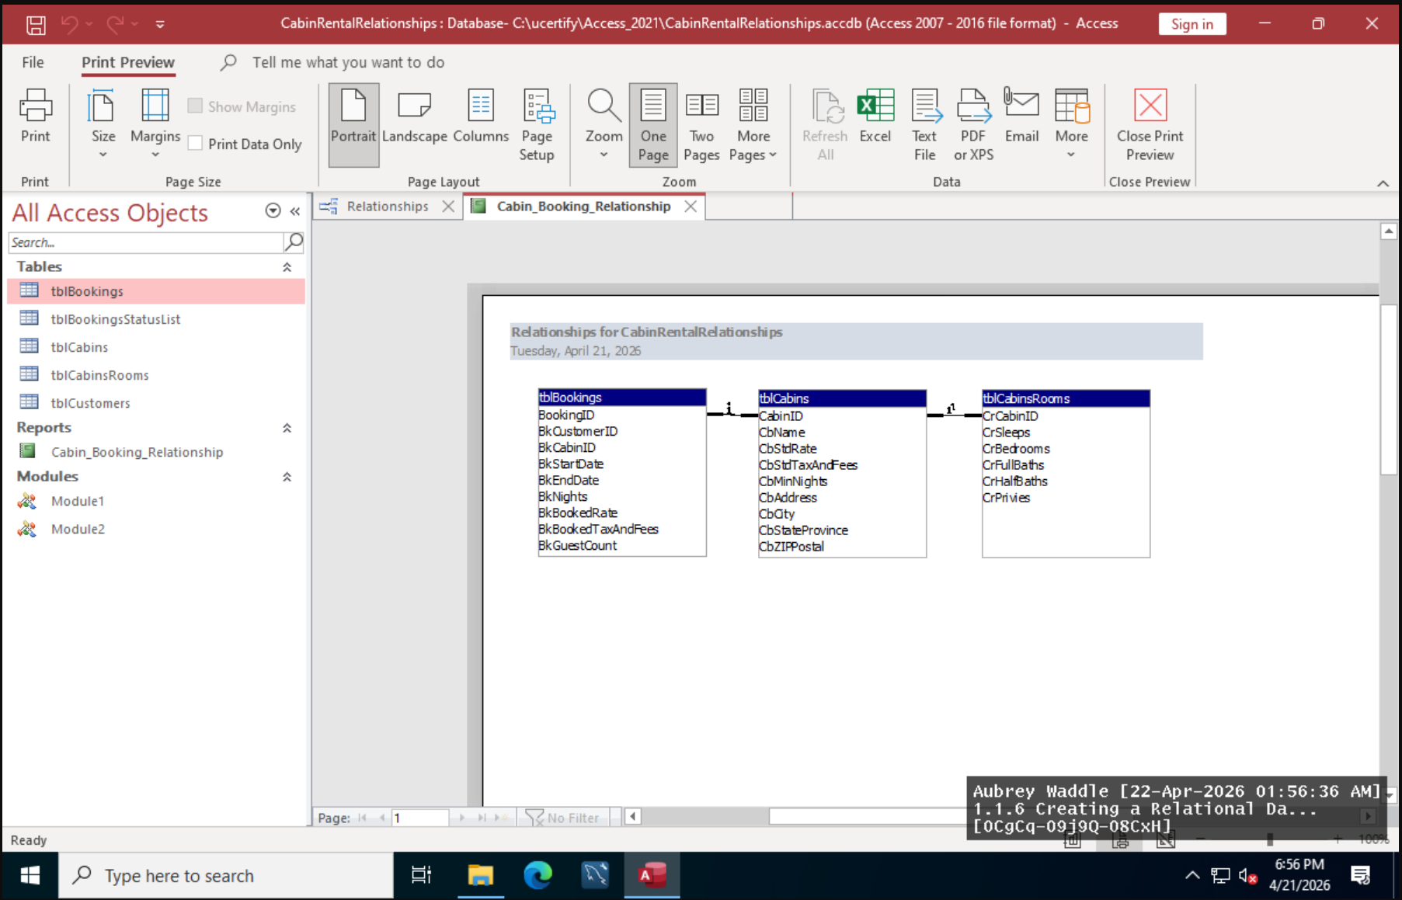

1.1.7
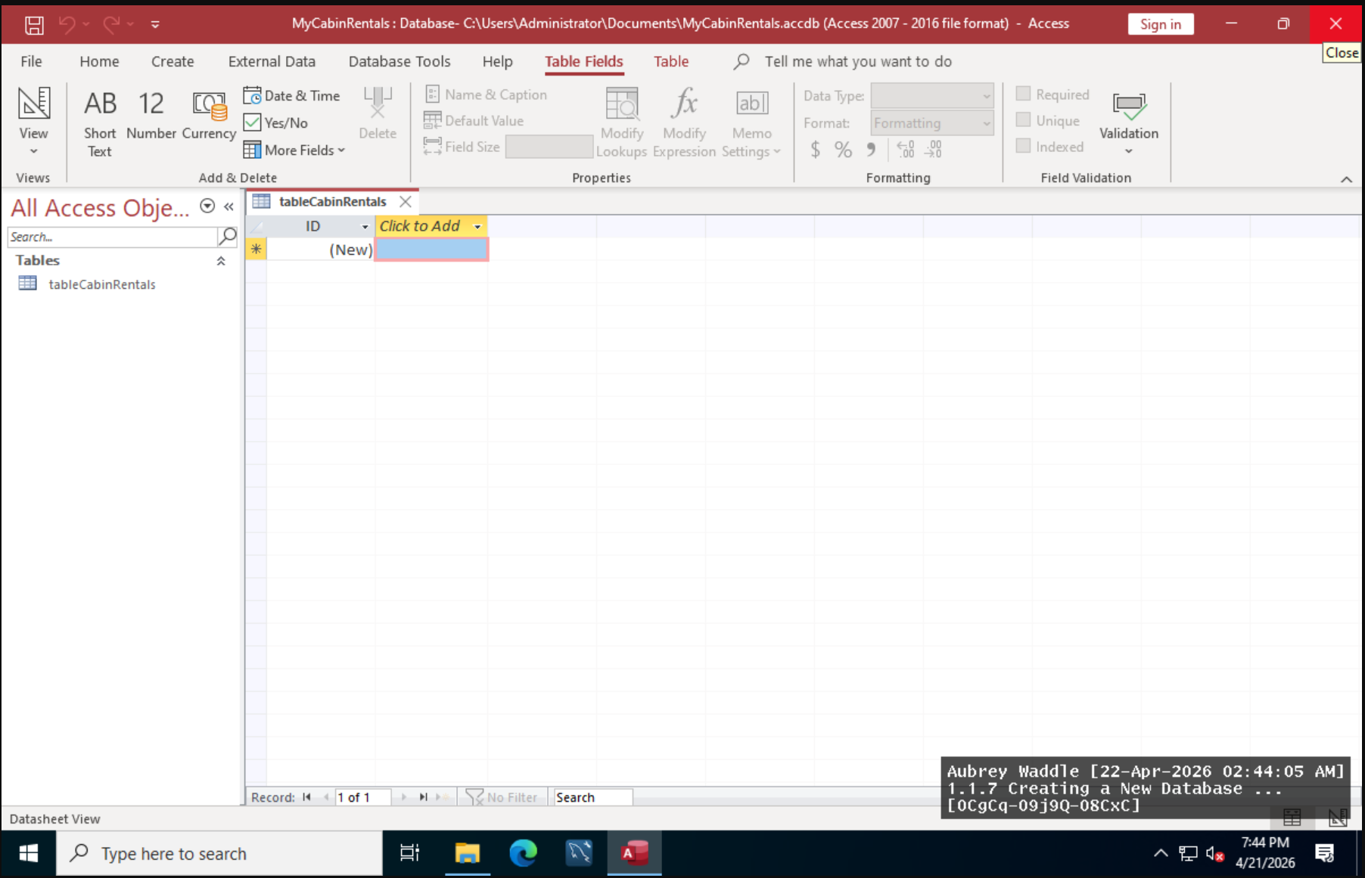

1.7.2

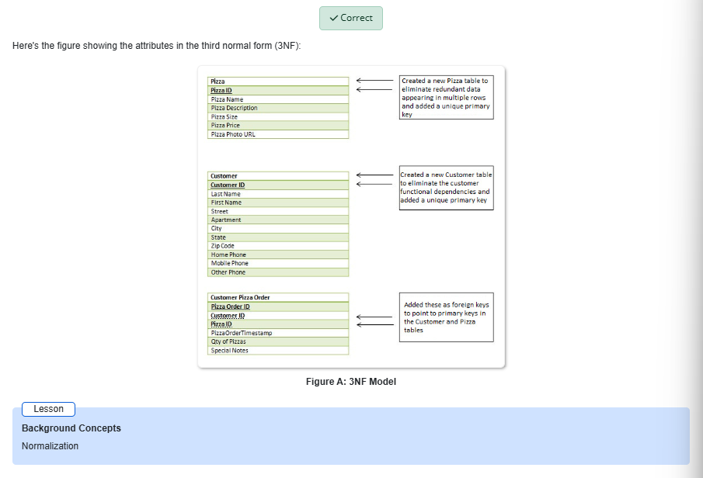
1.7.3
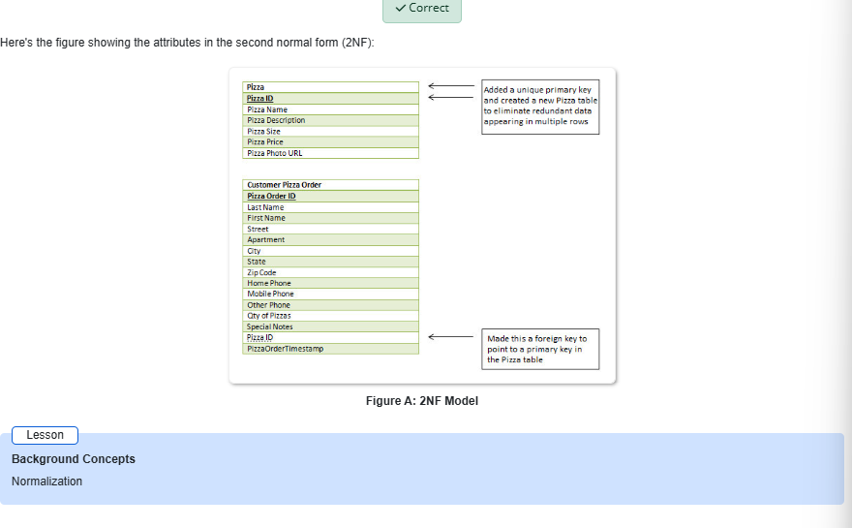

Lab Reflection

Lab 1.1.6

I learnt how to utilize Microsoft Access to construct a structured database in Lab 1.1.6. In the lab, you will build up primary and foreign keys and put data into tables, rows, and columns. This graph uses the relationships view to link the tables for rooms, cabins, and reservations. This approach shows how to use many tables to make sure the data is valid and reduce duplication. Access is superior than Excel when it comes to related data. These talents might enable persons who are in charge of technology, business studies, or management keep an eye on things. Relational systems let organizations, hospitals, shops, and other places communicate information more easily. A secure database may assist a booking organization maintain track of clients, sales, and rooms. A well-organized linked library lets you make good choices and reports. This lab revealed how crucial it is.

Lab 1.1.7

I learned how to use Microsoft Access to construct a database in lesson 1.1.7. I attempted to open an existing file using the File tab, choose a clean database template, give it a new name, and set up the database's format. In this lab, it was more crucial to set up and move about than to construct connections. On the other side, both laboratories needed to keep everything in order and write down data correctly. People who work in offices, as analysts, or as small company owners who need to set up simple systems for stock, records, bookings, or clients may all use these abilities. To deal with data, you need to know how to construct systems.

Lab 1.7.2

I switched a database from the second normal form to the third normal form in the 1.7.2 lab. I looked at entity tables and characteristics to identify the main and foreign keys. Then I organized the information about the pizza, the user, and the order. This proved that standardization gets rid of superfluous copies of data and makes it simpler to discover and use the relevant data. These strategies may help database managers, professionals, and system designers build databases that perform properly. They assist with daily duties and reports that require to maintain track of and gather information on customers, offers, and products.

Lab 1.7.3

In Lab 1.7, I learned more about how to make a database normal by changing data from the first normal form to the second normal form.3. I made a separate table for pizza-related qualities and used main and foreign keys to keep track of how they were linked. Before this lesson, I worked on databases, linked Microsoft Access files, and made sure that the data was in the third normal form. These tests show me that the way systems are set up makes them work better and faster. You can use these skills in business, as a reporter, or if you are in charge of money. Standardizing data fixes mistakes and makes everything more consistent. This makes it easy to keep track of things like service records, client orders, and inventory. The test showed that the database structure works better and is easier to use when big tables are broken up into smaller ones that are all connected to each other.

